The research team has developed technology supporting beyond-visual-line-of-sight (BVLOS) small unmanned aircraft systems (sUAS) operations within a defined airspace volume. The specific goal of demonstrating a low-cost, readily manufactured ground-based detect- and-avoid (GBDAA) radar has been achieved. In particular, a prototype radar has been build in the team’s lab at the Advanced Radar Research Center (ARRC) at the University of Oklahoma, and aircraft from the university’s Department of Aviation have been flown in specific patterns to confirm radar detections. The radar’s primary specifications are: 5.6 GHz operating frequency, 10 MHz to 20 MHz of operating bandwidth, 6.3 kW peak transmit power, maximum duty cycle = 10%, range = 5 km, probability of detection within range = 99.9%. As such, the radar will scan continuously, aiming for a high probability of detecting targets entering a 5 km range. Power supplies, a processing unit, an antenna, and radio frequency components for both transmitting and receiving signals have been designed for the radar. An experimental picture is depicted below.

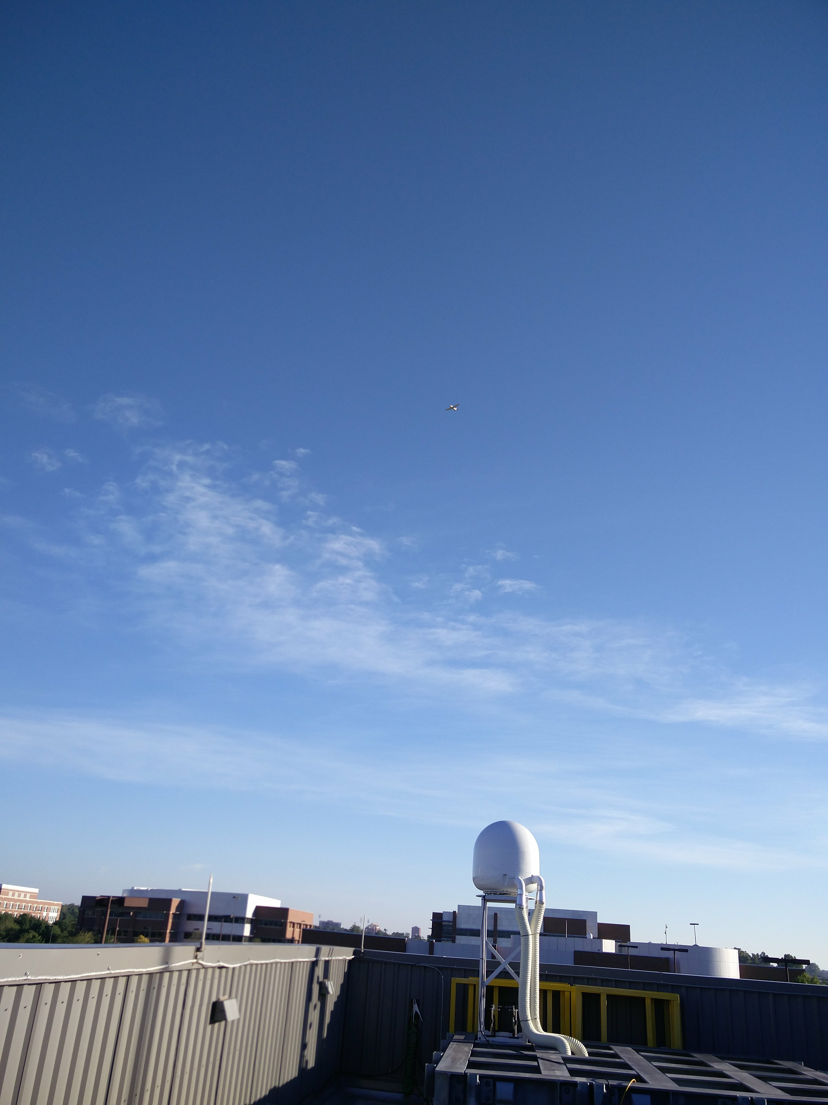

Figure . Radar mounted on top of the team's lab in Norman, OK.

The interior of the radar’s weatherized housing is depicted below:

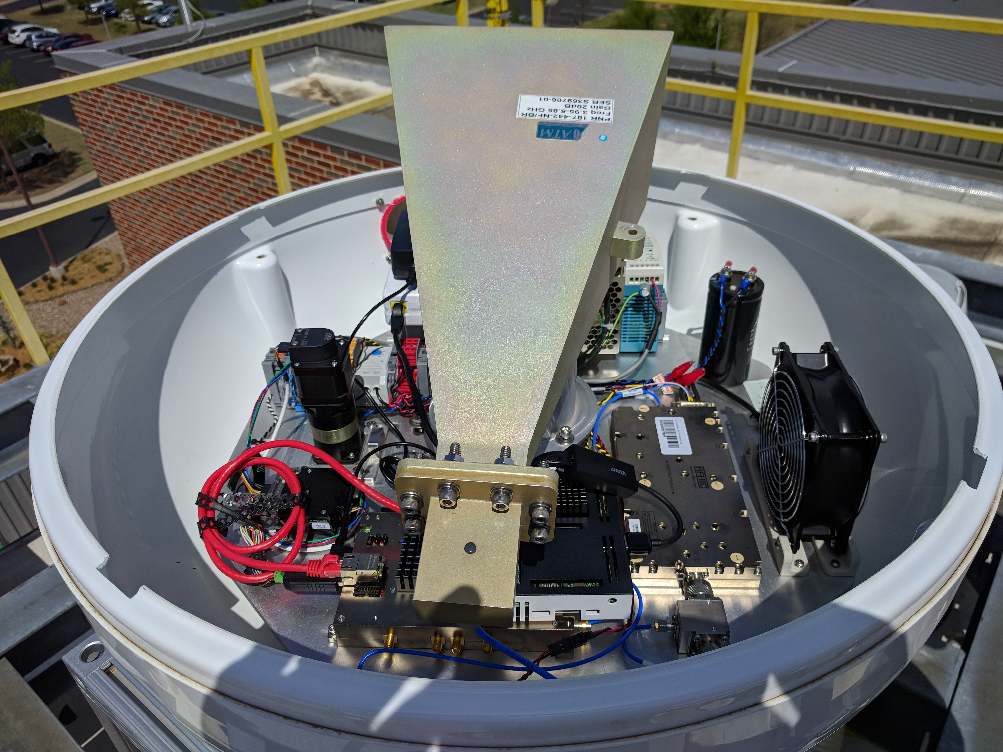

Figure . Interior view of the radar.

To detect targets, the team implemented an algorithm derived from a traditional Constant False-Alarm Rate (CFAR) detection algorithm. This algorithm uses radar data to estimate random noise levels and distinguish targets from noise. While operating, the GBDAA Radar generates a stream of measurements, each pointed in the current direction of the radar as it spins. Once the radar completes a full circle, the receiver has assembled a Plan Position Indicator (PPI). The second component of the program is our CFAR implementation, which plots detections on an image of the PPI. We were successful in running the program in real time, ideally allowing for immediate visualization of aircraft within the radar’s effective range. The program also saves data from completed PPIs and periodically stores the resulting visualization for later review. We have conducted several flight tests. The aircraft target used was a single-engine, four-seater Piper Warrior III, a common aircraft which served as a type specimen for the light aircraft GBDAA Radar was designed to detect. This test consisted of a series of maneuvers that aimed to test the capabilities of the GBDAA Radar. We developed a flight plan which ensured that the radar could view its target at many different altitudes and ranges.

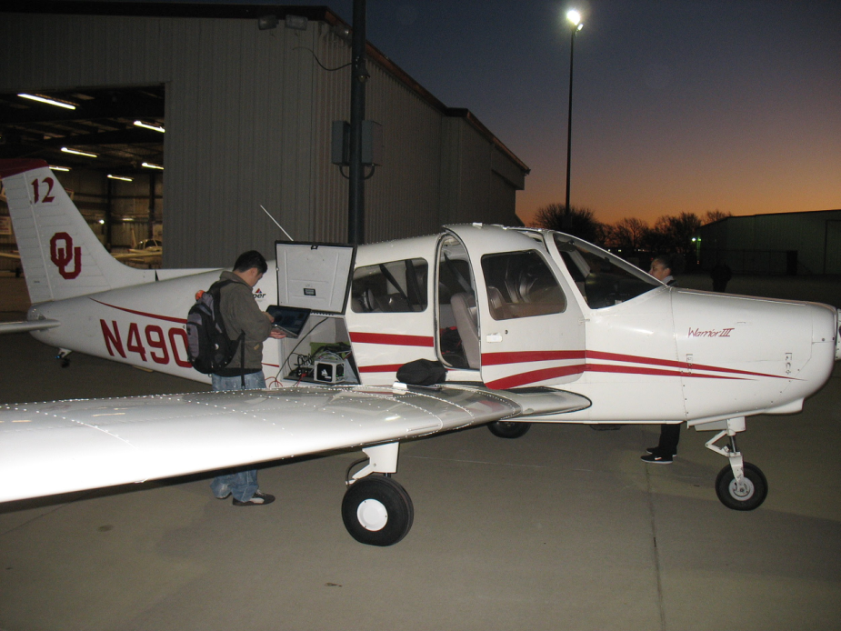

Figure . University aircraft used for radar detection experiments.

On February 26, 2018, the flight plan began with the plane approaching the location of the radar from the Max Westheimer Airport. The the Piper Warrior III airplane then proceeded to complete two figure-eight patterns of 1-mile radius loops. The plane then ascended to 1,500 feet, completed 2 passes over the radar, and ascended to 5,000 feet. The final maneuver of the plan was to complete a loop 4 miles in radius before returning to the airport. The route of the plan can be seen in Figure 4 below with the initial figure eight in red, the passes overhead in green, and the final loop in yellow.

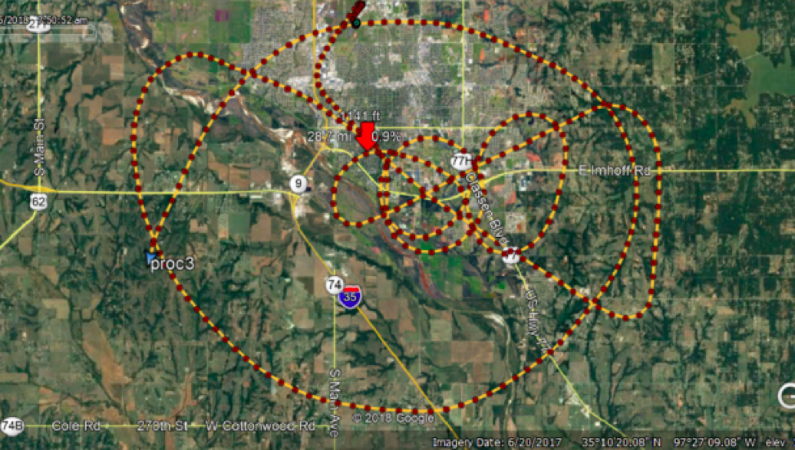

Figure 4. Flight path.

Specific detections are shown in the figure below. In particular the graph on the left depicts the behavior of the CFAR algorithm. The figure on the right depicts a set of detections in the lower-left quadrant. The right wedge in the left of the figure depicts strong reflections from a nearby water tower.



Figure . Left - detection algorithm performance , Right – several detections forming a track.

**Looking forward:** The team will be moving to X-band (approximately 10 GHz, as opposed to approximately 5 GHz in the C-band), for these reasons: (1) frequency authorizations are more readily available, (2) the gain of the antenna can be increased while maintaining a constant physical dimension. The team’s rev #1 digital transceiver will be used, so extensive software revisions will be simple.